2. Hash Tables
Aim:
Implement hash functions with different collision resolution techniques

Theory:

I. Hashing and Hash Table
Hashing is the technique that is generally used to identify an object, distinctively, from a group of large similar objects. One of the example of hashing is visible in universities, and schools, where each student is assigned a unique roll number. Banks also apply hashing technique to allow unique identification of each transaction carried out by all of it’s customers.
In hashing, a hash function converts large keys into small keys. The values are then stored in a data structure called hash table. Hashing distributes entries (key-value pairs) uniformly across the hash table. Each element is assigned a key, using which, the algorithm (hash function) computes an index that suggests where an entry can be found or inserted.
A hash table is a data structure that is used to store keys/value pairs. It uses a hash function to compute an index into an array in which an element will be inserted or searched.

II. Collision
The major responsibility of the hash function is to store data elements at unique indexes within the hash table. However, sometimes, this is not always possible. Thus, a collision is said to occur. A collision occurs when a hash function maps multiple keys onto the same table address. This collision must be resolved.

III. Collision Resolution Techniques
A. Separate Chaining
Implemented using linked lists, separate chaining is one of the most commonly used collision resolution techniques. Here, each element of the hash table is a linked list. Each element that is inserted into the hash table is inserted into a specific linked list. In case of collision, both the elements are stored in the same linked list. The cost of lookup here is that of scanning the entire selected linked list for the required key.

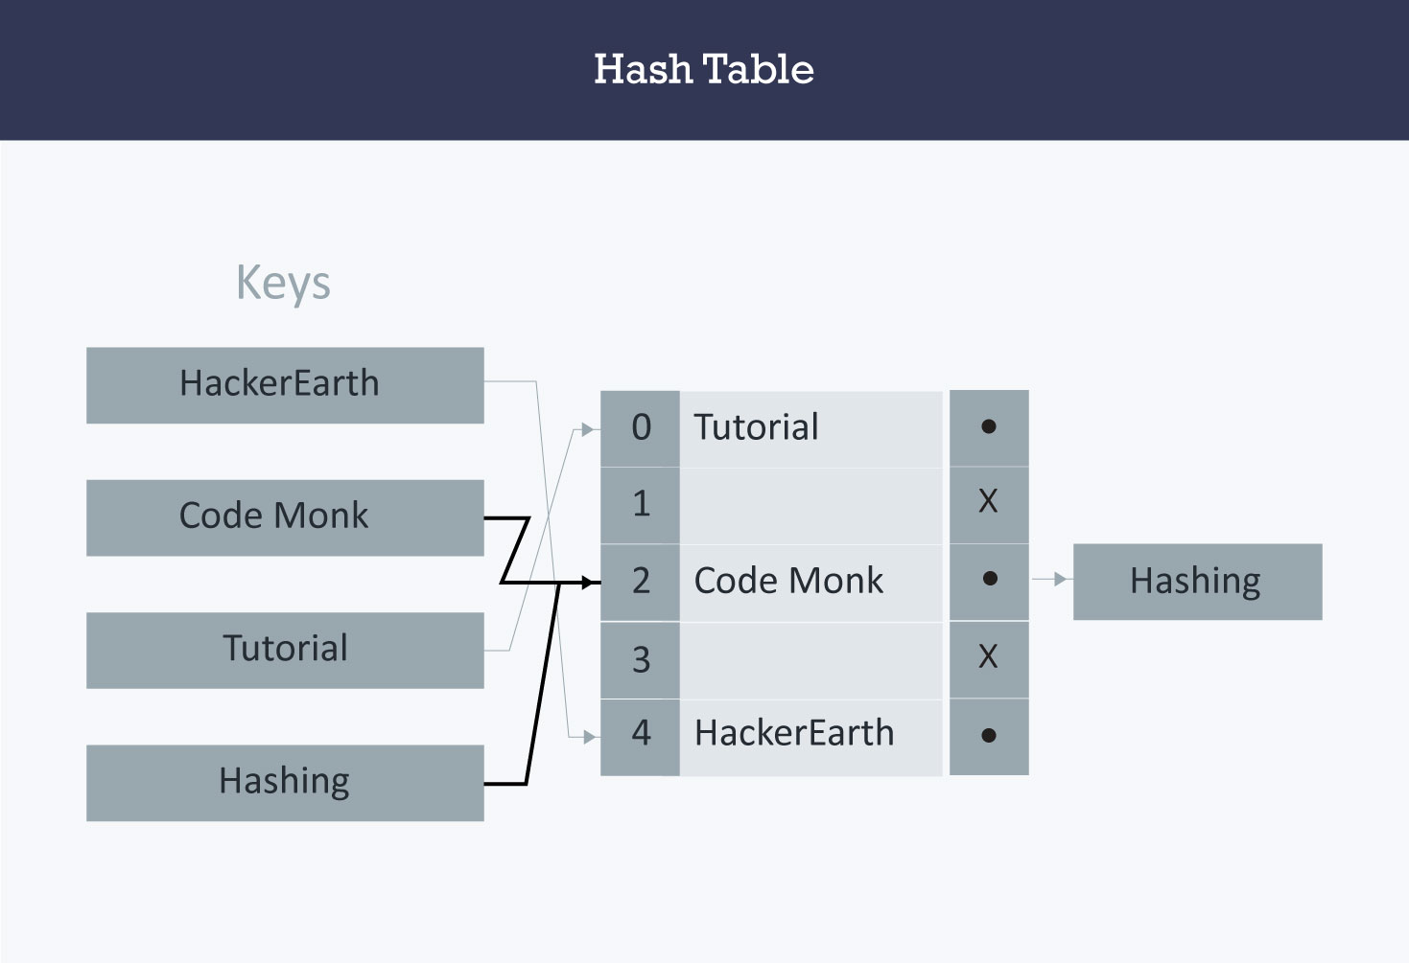

Fig 1. Collision Resolution in Hash Table using Separate Chaining

B. Linear Probing (Open Addressing or Closed Hashing)
In open addressing, all entry records are stored in the array itself, instead of storing it in linked lists. For a new entry to be inserted, a hash index on the key is computed and then the array is examined, starting with the hash index. If the slot at the hashed index is found to be unoccupied, then the entry record is inserted in that slot. Otherwise, it proceeds in some probe sequence and tries to find an unoccupied slot.
In different probe sequences, different intervals between successive entry slots or probes are allowed. When searching for an entry, the hash table is traversed in the same sequence until either the required key is found or an unused slot is found, which indicates that the required key is not present in the table.
Linear Probing usually leads to the primary clustering phenomenon, where elements tend to be clustered around their original hashed indexes. These primary clusters may combine to form larger clusters which causes longer probe sequences and hampers efficiency.
The probe sequence for linear hashing is defined as:
h_{i} (key) = [h(key) + i] % tableSize for i = 0, 1, . . . , tableSize – 1
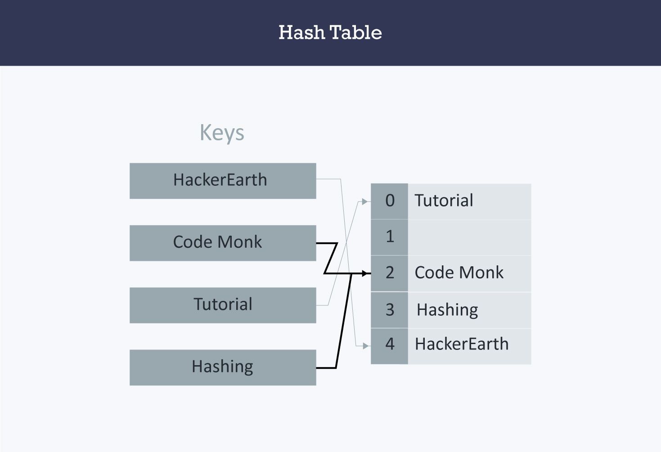

Fig 2. Collision Resolution in Hash Table using Linear Probing

C. Quadratic Probing
Similar to linear probing, is another technique called Quadratic Probing. The only difference is in the interval between successive probes. When the slot at a hashed index for a key is already occupied, traversing must start until an unoccupied slot is found. This interval between slots is calculated by adding the value of an arbitrary polynomial in the original hashed index.
The probe sequence for quadratic probing is defined as:
h_{i} (key) = [h(key) + i²] % tableSize for i = 0, 1, . . . , tableSize – 1
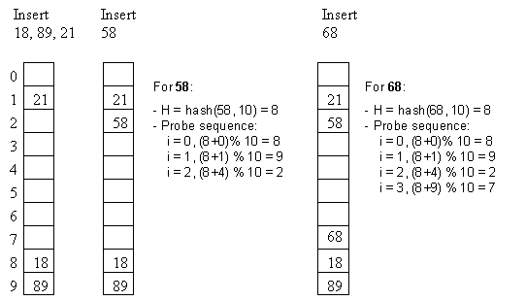

Fig 3. Collision Resolution in Hash Table using Quadratic Probing

Implementation:

1. Linear Probing
#include<stdio.h>
#include<stdbool.h>

//status flags:
//0 - Empty
//1 - Occupied
int value[50], status[50], count;
bool flag;

//Util Functions
void insert(int key, int pos, int size) {
flag = false;
if(status[pos] == 0) {
value[pos] = key;
status[pos] = 1;
flag = true;
count++;
printf("\n%d was inserted at %d position",key,pos);
printf("\n%d elements are present in the array",count);
if(count >= (size/2)) {
printf("\nWARNING : Upto half of the table is filled...it is advisable to stop inserting more elements to prevent the implementation from failing\n");
}
}
if(status[pos] != 0) {
while(flag != true) {
if((pos+1) <= (size-1)) {
insert(key, pos+1, size);
} else if((pos+1) > (size-1)) {
pos = 0;
insert(key,pos,size);
}
}
}
}
void find(int key, int pos, int size) {
flag = false;
printf("\nTrying to search at position : %d",pos);
if(status[pos] == 0) {
printf("\nERROR: Search Unsuccessful!");
}
else if(status[pos] == 1) {
if(value[pos] == key) {
flag = true;
printf("\nSearch successful! Found %d at %d",key,pos);
}
else if(value[pos] != key) {
while(flag != true) {
find(key,(pos+1)%size,size);
}
}
}
}
void main() {
int key, ch, pos, x, size;
flag = false;
count=0;
size=0;
printf("Enter the size of hash table: ");
scanf("%d",&size);
printf("\n");
//Insert operations
do {
printf("Enter the key you want to insert... ");
scanf("%d",&key);
pos=key%size;
insert(key,pos,size);
printf("\nEnter 1 to insert more elements and 2 to stop inserting elements");
scanf("%d",&ch);
} while(ch != 2);
ch = 0;
//Search Operations
do {
printf("\nEnter the key that you want to find... ");
scanf("%d",&key);
pos=key%size;
find(key,pos,size);
printf("\nEnter 1 to find more elements and 2 to stop search operations");
scanf("%d",&ch);
} while(ch != 2);
}

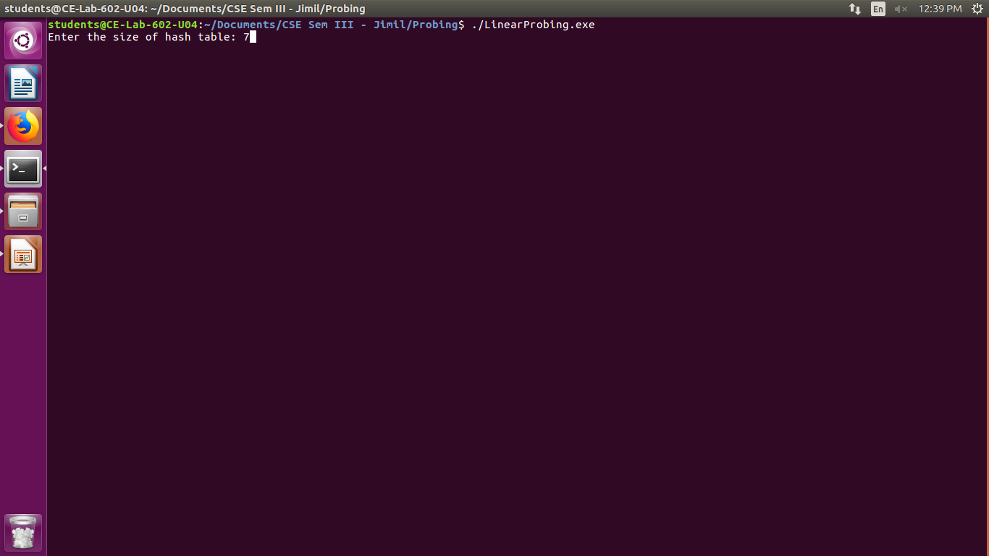
Output:

Fig 4.1. Linear Probing – Get size of the table
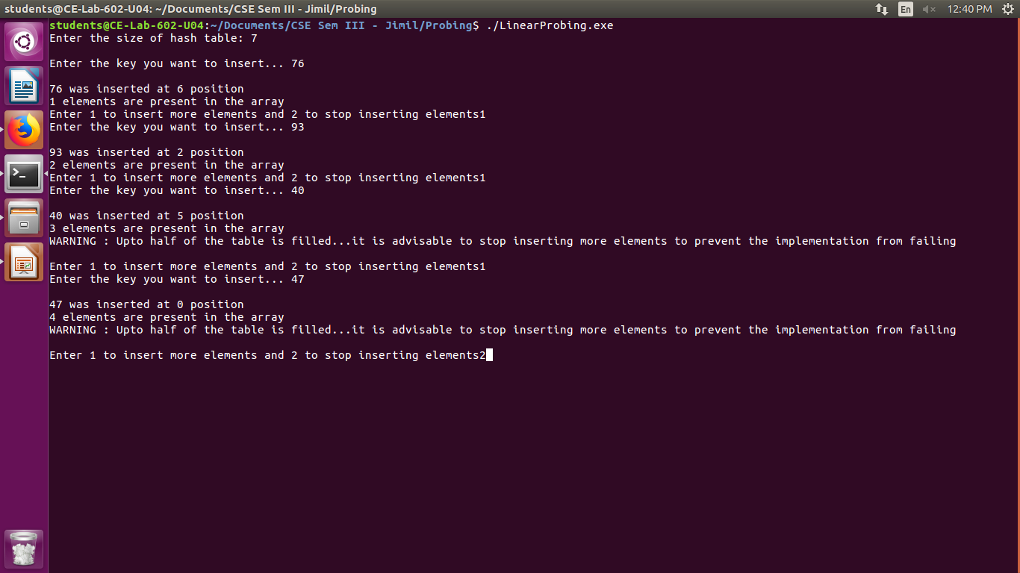
Fig 4.2. Linear Probing – Insert keys into the hash table
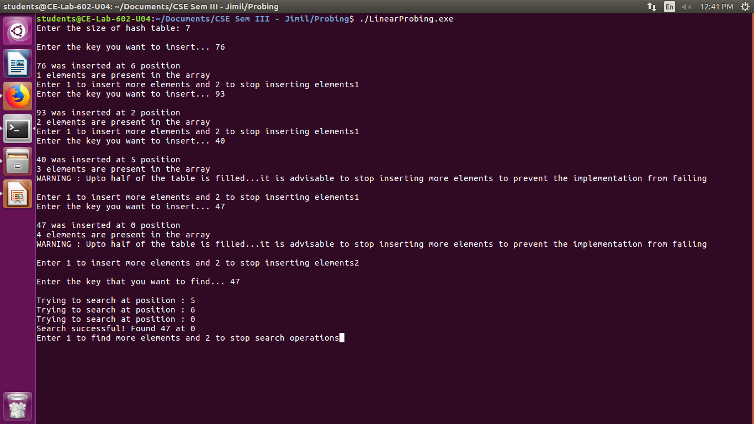
Fig 4.3. Linear Probing – Search keys in the hash table

2. Quadratic Probing
#include<stdio.h>
#include<stdbool.h>

//status flags:
//0 - Empty
//1 - Occupied
int value[50], status[50], count, m = 0;
bool flag;

//Util Functions
void insert(int key, int pos, int size, int initpos) {
int initpos1;
initpos1 = initpos;
flag = false;
if(status[pos] == 0) {
value[pos] = key;
status[pos] = 1;
flag = true;
count++;
printf("\n%d was inserted at %d position",key,pos);
printf("\n%d elements are present in the array",count);
if(count >= (size/2)) {
printf("\nWARNING : Upto half of the table is filled...it is advisable to stop inserting more elements to prevent the implementation from failing\n");
}
}
if(status[pos] != 0) {
while(flag != true) {
printf("\nCOLLISION OCCURED, GONNA TRY QUADRATIC PROBING");
if(flag == true) {
break;
}
m++;
insert(key,(initpos1+(m*m))%size,size,initpos1);
}
}
}
void find(int key, int pos, int size, int initpos) {
int initpos1;
initpos1 = initpos;
flag = false;
printf("\nTrying to search at position : %d",pos);
if(status[pos] == 0) {
printf("\nERROR: Search Unsuccessful!");
flag=true;
return;
}
else if(status[pos] == 1 && flag == false) {
if(value[pos] == key) {
flag = true;
printf("\nSearch successful! Found %d at %d",key,pos);
return;
}
else if(value[pos] != key) {
while(flag != true) {
printf("\nCOLLISION OCCURED, GONNA TRY QUADRATIC PROBING");
if(flag == true) {
break;
}
m++;
find(key,(initpos1+(m*m))%size,size,initpos1);
}
}
}
}

void main() {
int key, ch, pos, x, size, initpos;
flag = false;
count=0;
size=0;
printf("Enter the size of hash table: ");
scanf("%d",&size);
printf("\n");
//Insert operations
do {
printf("Enter the key you want to insert... ");
scanf("%d",&key);
pos=key%size;
initpos=key%size;
m=0;
insert(key,pos,size,initpos);
printf("\nEnter 1 to insert more elements and 2 to stop inserting elements");
scanf("%d",&ch);
} while(ch != 2);
ch = 0;
initpos = 0;
//Search Operations
do {
printf("\nEnter the key that you want to find... ");
scanf("%d",&key);
pos=key%size;
initpos=key%size;
m=0;
find(key,pos,size,initpos);
printf("\nEnter 1 to find more elements and 2 to stop search operations");
scanf("%d",&ch);
} while(ch != 2);
}

Output:
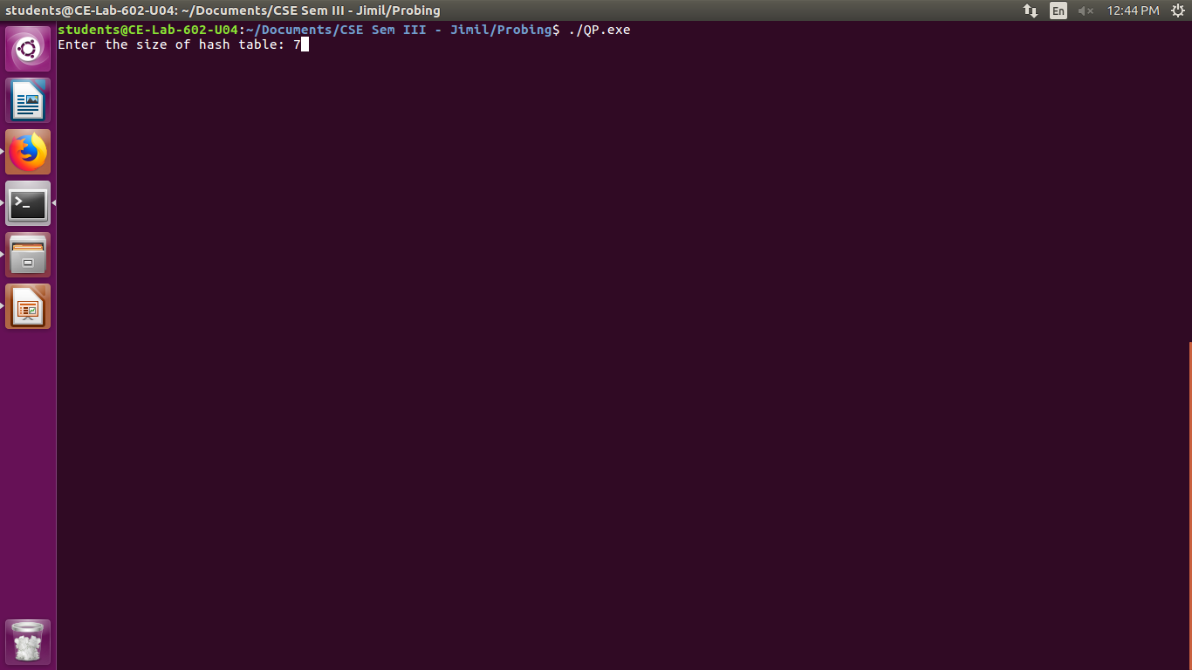
Fig 5.1. Quadratic Probing – Insert size of the hash table

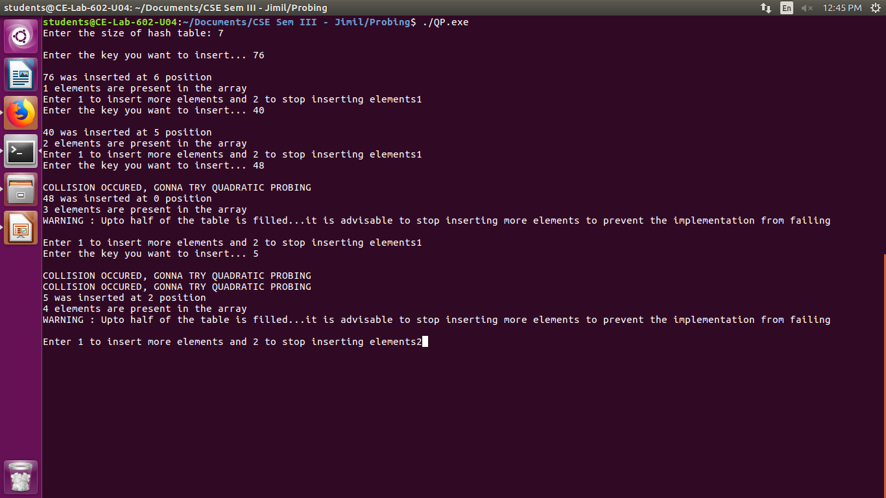
Fig 5.2. Quadratic Probing – Insert keys in the hash table
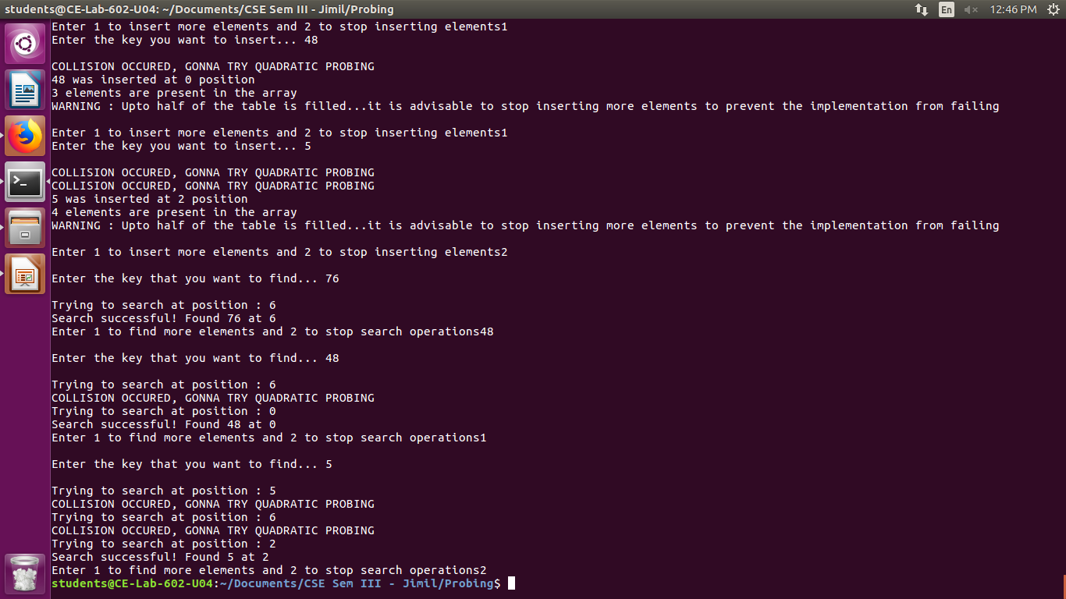
Fig 5.3. Quadratic Probing – Search keys in the hash table

Result:
Thus, we studied the use of linear and quadratic probing to resolve collisions in hash tables.
We observed that linear probing lead to the problem of primary clustering which hampered the efficiency of the algorithm.
Thus, to resolve that problem, we used quadratic probing, where the probe sequence used steps of i². However, we also observed that once the table was half full, the chances of the failure of the algorithm increased.

Conclusion:
Our goal should be to create a hash function that minimizes the number of collisions, is efficient and easy to compute, and evenly distributes keys across all possible hash values.
Thus, in this experiment, we have implemented hash table, along with collision resolution strategies – linear probing and quadratic probing.

